 | 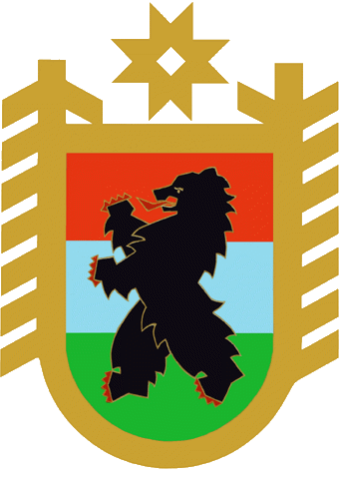 | The II International Innovative Forum :  “Hyperborea: Youth In Action”  3-9 of August 2010
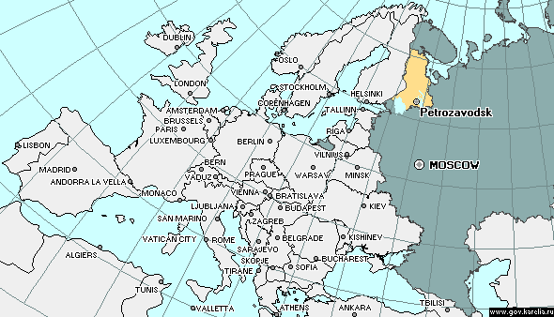 |  |  | The Forum will take place in  Russia, the Republic of Karelia , Petrozavodsk  - From Moscow to Petrozavodsk is about 1000 km  - From St.Petersburg to Petrozavodsk is 400 km  - From Helsinki to Petrozavodsk is 700 km  - The participants of the Forum will reside in the tents at the picturesque bank of the lake  1500 participants from Russia and 40 countries of the world, young people from 16 to 28 years old
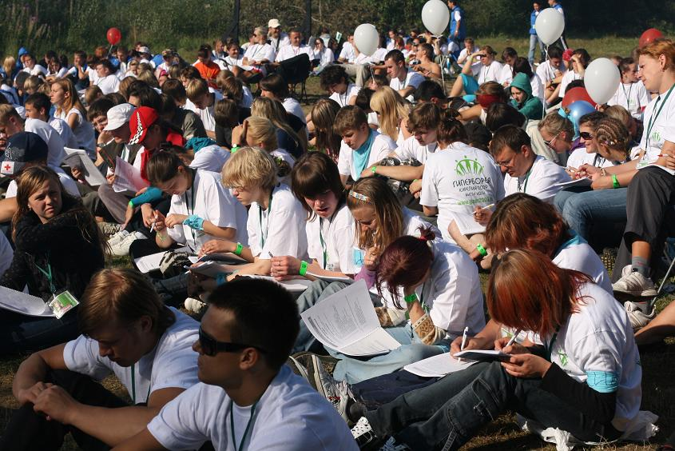 |  |  | - Meetings with the successful persons  - Russian traditions and culture  - Workshops on the issues of hospitality  - Expedition activity  - Discussions on youth policy  The Organizers of the Forum :  The State Committee of the Republic of Karelia On Youth Affairs  State Organization “Karelian Regional Youth Center”
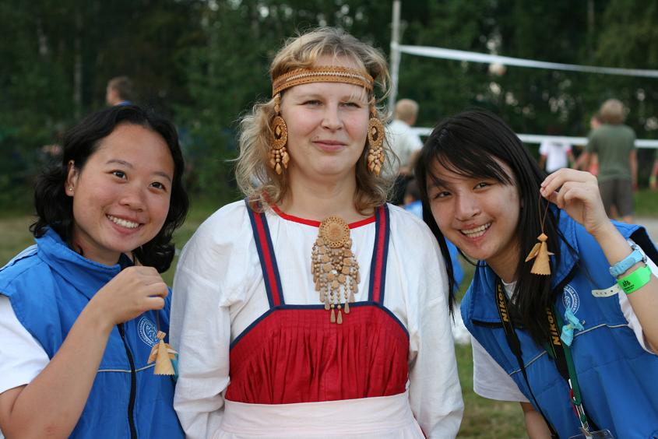 |  |  | Official languages: Russian and English  The requirements to take part in the Forum:  - Registration fee - 50 Euro  -transport costs are paid by the participants themselves  -visa and invitation are paid by the participants themselves
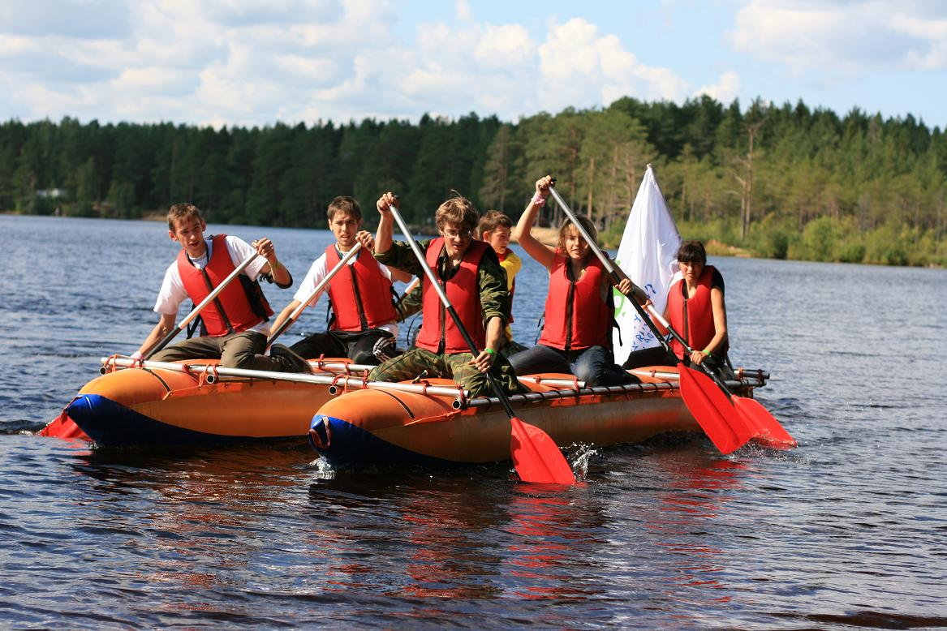 |  |  | Registration deadline is the 1st of July 2010 on karelia2010@mail.ru.  All the necessary information about the forum:  www.giper2010.ru  (88142)562224, fax (88142)560625.  Our contact email address is karelia2010@mail.ru
We are looking forward to meeting you in Karelia!

